Dear colleagues

GPC England ballot for GP contractors / partners –
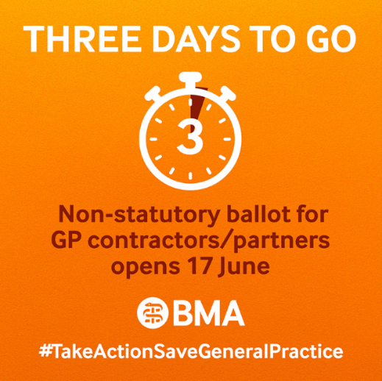
Protect Your Practice, Protect Your Patients
Vote YES and use the BMA GP Practice Survival Toolkit

It is now only three days to go until 17 June when the ballot to Save General Practice opens. We are holding this non-statutory ballot because general practice has been deliberately broken. Over 1,300 practices have been lost, and thousands more GPs with them. Funding for essential practice services has eroded to the tune of £660 million and successive sub-inflationary uplifts have threatened practices’ viability. With almost 2000 fewer FTE GPs compared with a decade ago, and an additional 6.4million patients it is no surprise that patient dissatisfaction has doubled in the past five years.

In the referendum earlier this year almost every single one of you said a firm NO to the new contract and you were ignored by the Government, who have refused to make any improvements or give general practice any more resources.

This ballot is open to all GP contractors and partners in England. If you’re not yet a member you can join the BMA now to ensure you have your vote. And what’s more, any new member joining from 17 June, will get their first 3 months of membership for free: www.bma.org.uk/join

The Ballot Question:

‘Are you prepared to undertake one or more examples of collective action as outlined in the BMA campaign to Protect Your Patients, Protect Your Practice?’

The Ballot Answer

Vote YES to Take Action to Save General Practice.
Vote YES to protect your practice and to protect your patients.
We are not asking you to breach your contact, but we are asking you to take a stand.

The ballot opens 17 June and closes on 29 July ahead of action commencing from Thursday 1 August.


Read our GP campaign page for more information about the ballot, contract guidance, and how to order campaign materials: www.bma.org.uk/gpcontract

What will the menu of actions look like?
We will be inviting GP Partners to work with their practice management team and, working in liaison with their LMC, determine the actions they will be willing to take. Each of these actions is outlined in the BMA GP Practice Survival Toolkit

It is for each practice to pick and choose as they see fit. You may decide to add to your choices over the days, weeks, and months ahead. This is a marathon, not a sprint.

PCN DES 2024/25 GPC England Guidance on the Capacity and Access Improvement Payment (CAIP)
There are three separate and discrete elements to the CAIP within the 24/25 PCN DES:
- Faster care navigation, assessment, and response
- Better digital telephony
- Simpler online requests

GPC England guidance is that practices should defer signing declarations of completion for “better digital telephony” and “simpler online requests” until further GPC England guidance in early 2025.

Read our Focus on guidance

GPC England recommends PCNs do not confirm compliance with the on-line platform CAIP element at this time, because unless the workload associated with a practice’s on-line platform can be controlled, it will not be possible for practices to effectively implement the BMA Safe Working Guidance.

GPC England recommends PCNs do not confirm compliance with better digital telephony CAIP element at this time as NHS England has signalled its intention to issue a contract variation notice from October 2024 to make the sharing of the eight call data metrics they have identified contractual.

GP Contract guidance and campaign materials
We have now published our 2024/25 contract guidance documents, to help you consider how best to approach the contract changes. These documents cover the following areas:

- Dispensing and prescribing
- GP data sharing and controllership
- Limited Liability Partnerships and the GMS contract
- Medical Associate Professions in General Practice
- 2024 Premises Cost Directions
- Use of enhanced access appointments
- Vaccinations and Immunisations
- Proformas and referral forms
- Spending and the PCN DES capacity and access payment funding

We have also produced campaign infographics for you to attach to your emails, practice website and socials, as well as PPG and patient-facing resources – all of which are available to download from the BMA website or to be ordered directly BMA Reps Hub.

See the GP campaign page for more information about the ballot and how to order materials.

The GPsOnYourSide Campaign page is for practices to share, should you wish, with patients.

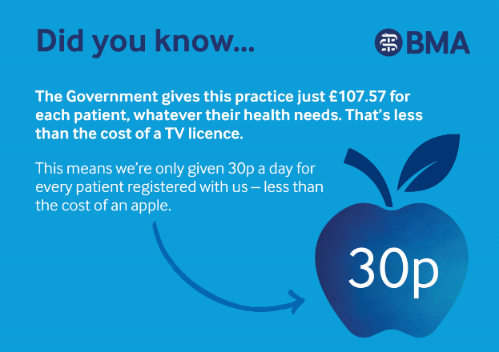
BMA.org.uk/GPsOnYourSide Public-facing campaign

We have produced campaign posters, presentation slides and infographics for you to attach to your emails, practice website and socials, as well as PPG and other patient-facing resources – all of which are available to download from the BMA website

The GPsOnYourSide Campaign page is ready for practices to share with patients and the public.

Campaign materials for GPs and practice teams

GP Survival Toolkit cards to fit inside GPs Are On Your Side lanyards, window stickers, posters, badges and leaflets are now able to be ordered directly from the BMA Reps Hub.

See the GP campaign page for more information about the ballot and how to order materials.



GPC England Officer Team face-to-face contract roadshows

The GPC England officer team are currently travelling the country in a series of over 20 roadshows, hosted by regional LMCs. This is an opportunity to hear face-to-face about the action practices will be able to take, details about the ballot, expert leading counsel advice, collection of your practice resources, and a chance to discuss and debate with your peers.

The roadshow events are taking place across England from now until 24 July and are open to all GP contractors/partners and practice managers, salaried GPs, GP registrars and practice nurses. You do not need to be a BMA member to attend, so please invite your colleagues and ensure there is representation from every practice in your locality.

There are also a number of virtual webinars, which will be open to all.

See the list of events across the country and register here

BMA membership details
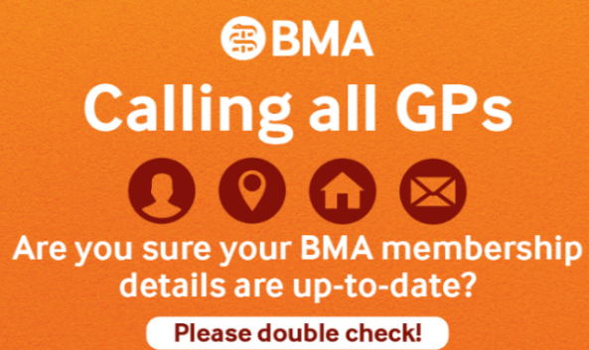
It is vital that you keep your BMA membership details up to date so you can vote in our ballot. To vote, we need you to login to www.bma.org.uk and check your details are current and correct. We must have the right information for your vote to count, so please check.

Please look out for an email from bma@cesvotes.com which will allow you to vote.
We need:
- Your personal details, including a valid email address
- Place of work details for all your roles
Your details MUST be up to date for your vote to count.

In this first ballot, GP contractors / partners need to vote YES to send a message to Government that we are ready to stand up for a better service for our patients, and to protect our practices.

Please check and update your details here BMA - Sign In

BMA Membership offer

Non-members still have time to join in the ballot. Any new member joining from 17 June, will get their first 3 months of membership for free. The latest date to join for the vote to be counted is 22 July. Please encourage your colleagues to join: bma.org.uk/join

Parliamentary Constituency Dashboard
Bedfordshire & Hertfordshire LMC has created a Parliamentary Constituency Dashboard, designed to help GPs and LMCs to present General Practice data to their local Members of Parliament (or Parliamentary Candidates in the upcoming election). Select the region of the country and the constituency from the dropdown menus and you should get all the data from that constituency. Launch the tool here (best viewed on a PC or tablet).

Contraceptive services
Contraceptive services, formerly an Additional Service funded by an identified 2.4% of Global Sum, have been included as an Essential Service under the Primary Medical Services (GMS/PMS) Contract, since 2020. This includes the treatment of and prescribing for patients for contraceptive services, with the specific exclusion of the “fitting and implanting of intrauterine devices and implants”.

In addition, Para 14(2)1 of the GMS/PMS contract includes a reference to “drugs” including contraceptive as substances and “appliances” as including contraceptive appliances.

GPC England’s advice is therefore that the prescription and administration of contraceptive infections (such as Depo Provera, Sayana Press, and Noristerat) does form part of Essential Services. Reimbursement is available through the Personally Admitted drugs provisions in the Statement of Financial Entitlements and indemnity is available via CNSGP.

Seasonal Flu Immunisation Programme QIVr vaccine
Sanofi has advised that the Recombinant Quadrivalent Influenza vaccine [QIVr] will, due to a supply issue, not be available for the flu vaccination programme for the 2024/25 season.

The original JCVI recommendation was to use QIVr for adults aged 65 years and over, and also adults aged 16 to 64 who are in eligible groups.

In the light of this change, NHS England has advised the following:
Aged 65 years and over | Aged 18 to 64 years in risk groups
- adjuvanted quadrivalent influenza vaccine (aQIV)  - high-dose quadrivalent influenza vaccine (QIV-HD)  The cell-based quadrivalent influenza vaccine (QIVc) can also be considered only when every attempt to use aQIV or QIV-HD has been exhausted – evidence of this may be requested by the commissioner before reimbursement is agreed. | Aged 18 to 59 years  - cell-based quadrivalent influenza vaccine (QIVc)  Aged 60 to 64 years  - cell-based quadrivalent influenza vaccine (QIVc)  - high-dose quadrivalent influenza vaccine (QIV-HD)  The egg-grown quadrivalent influenza vaccine (QIVe) can also be considered only when every attempt to use QIVc, or in the case of those aged 60 -64 years also QIV-HD, has been exhausted – evidence of this may be requested by the commissioner before reimbursement is agreed.

As QIVr is only licensed for those aged 18 and over, this does not affect the immunisation programme for younger patients. For practices who have ordered QIVr, and who are participating in the 2024/25 immunisation programme, the primary alternative is QIV-HD [high dose quadrivalent influenza vaccine] which is licensed in the UK for those 60 and over. Otherwise, practices may seek to order additional supplies of aQIV [Adjuvanted Quadrivalent Influenza Vaccine] for those aged 65 and over, and QIVc [Cell-based Quadrivalent Influenza Vaccine] for those under 65 years.

NHSE has updated the list of influenza vaccines marketed in the UK

GP Appointment data – April 2024
The latest appointment data shows that that around 30.5 million standard appointments were booked in April 2024, with an average of 1.45 million appointments per working day. Over the past year, approximately 359.6 million standard (non-Covid-19 vaccination) appointments were booked. When comparing to pre-pandemic levels, this is around 57.3 million more appointments than between May 2019 to April 2020.

In terms of access, the proportion of appointments booked to take place the same day has increased slightly from the previous month: 44.6% of appointments in April 2024 were booked to take place on the same day, compared to 43.9% in March 2024. Face-to-face appointments remained the same as the previous month, around 65%. See more data showing the pressures in general practice >

Empowering sessional GPs week
‘Empowering sessional GPs’ week was held this week, dedicated to celebrating and empowering sessional GPs. GP partners also benefitted from content promoting the advantages of offering the model contract to their employees, alongside guidance on ensuring good working practices. The goals were to promote professionalism, fairness and wellbeing within the sessional GP workforce. During the week, the new GP Diary app, which helps GPs understand their working patterns, and the annual leave calculator that simplifies leave entitlement calculations, were highlighted. Read more

NHS Education Funding Agreement 2024/27
NHSE has published a new NHS Funding Agreement. Unlike the previous education contract, this new version includes GP-specific elements in schedule 1. The contract creates a formal mechanism for training practices to receive payment from NHSE.

GPC England has had the opportunity to review and comment on the funding agreement during its development and is content with the final version.

All of the funding agreement documentation can be accessed on the NHS England website. If they haven’t already done so, NHS England commissioners will be contacting training practices shortly about bringing you onto the new agreement.

Wellbeing resources
We continue to encourage practices to focus on their own team’s wellbeing and take time to reflect on what can be done to protect it (this will also meet the requirements of QOF quality improvement project on staff wellbeing. A range of wellbeing and support services are also available to doctors, from the BMA’s counselling and peer support services, NHS practitioner health service, Samaritans and Doctors in Distress. See also our poster with 10 tips to help maintain and support wellbeing.

GPC England committee pages and guidance for practices
Read more about the work of GPCE and practical guidance for GP practices. See the latest update on X @BMA_GP and read about BMA in the media. Contact us: info.GPC@bma.org.uk

Read the latest GPC England bulletin

Dr Katie Bramall-Stainer
GPC England chair
Email: KBramall-Stainer@bma.org.uk

